# Topic: Recommendation Engine

**Instructions**

Please share your answers filled inline in the word document. Submit Python code and R code files wherever applicable.

Please ensure you update all the details:

**Name: Batch Id:**  **Topic: Recommender Engine**

1. **Business Problem**
   1. **Objective**
   2. **Constraints (if any)**
2. **Work on each feature of the dataset to create a data dictionary as displayed in the below image:**

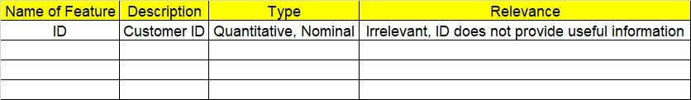

**Using R and Python codes perform:**

1. **Data Pre-processing**

**2.1 Data Cleaning and Data Mining.**

1. **Exploratory Data Analysis (EDA):**
   1. **Summary**
   2. **Univariate analysis**
   3. **Bivariate analysis**
2. **Model Building**
   1. **Build the Recommender Engine Model on the given data sets.**
   2. **Use UBCF technique for getting recommendations.**
3. **Share the benefits/impact of the solution - how or in what way the business (client) gets benefit from the solution provided.**

# Note:

The assignment should be submitted in the following format:

* R code
* Python code
* Code Modularization should be maintained
* Documentation of the model it can be word of PDF format (elaborating on steps mentioned above)

**Standard Grading Guideline :**

Grade A: All assignments submitted correctly on Time (with all mentioned content like: python code, r code, documentation)

Grade B: All assignments submitted but post the due date. Or Partial assignments are submitted.

Grade C and Grade D: Partial assignments submitted with incorrect answers, or worked on only R or Python or not all the content is submitted.

Grade F: Partial assignments submitted with incorrect answers and not all the content is submitted.

Q) Build a recommender system with the given data using UBCF.



**Problem Statement: -**

This dataset is realted to the video gaming industry and a survey was coducted to build recommendation engine so that the store can improve the sales of its gaming DVD’s. Snapshot the dataset is given below build a recommendation engine and suggest top selling dvds to the store customers.

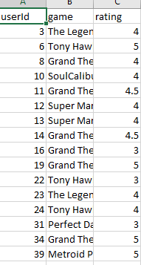

**Problem Statement: -**

The Entertainment Company, which is a startup online movie watching platform, wants to improvise its collection of movies and showcase those that are highly rated, and recommend those movies to its customer by their movie watching footprints. For this the company has collected its data and shared it with you to provide some analytical insights and also to come up with a Recommendation Algorithm so that it can automate its process for effective recommendations based on Users Interest and behavior patterns.

Remember the ratings are between -9 to +9.

